REGISTRATION FORM OF 4rd GCBSS CONFERENCE 2016

November. 14-15, 2016, Dubai (United Arab Emirates)
http://gcbss.org/cibssr/registration.php

4th GCBSS 2016 Dubai Conference will be held during November. 14-15, 2016 in Radisson Blu Hotel, Dubai Diera. Please note that it is essential for all participants to email the filled Registration Form (.doc/.docx/), Proof of payment receipt to ids: gcbss2016@gmail.com and Cc to admin@gcbss.org

SECTION 1: CONTACT INFORMATION
Paper ID Code: For example CIBSSR -00101
Name that you would like get printed on the certificate:

Conference Title: 4th Global Conference on Business and Social Science, Dubai, UAE
Whether attend the Conference: € Yes € No
Position (Professor/Associate Prof/Assistant Professor/Lecturer/PhD Student/Master Student/other):

Full Affiliation/Organization/University and country Name:
(that you like get printed on the certificate)

Conference Track: i.e. Accounting |  | Are you willing to serve as a session chair: (Yes (No
Session Type: € Oral Presenter € Observer € Visual Presenter
Telephone: | Mobile: |  | Email:
Special Needs or Dietary Requirements: € Yes € No
Student ID Number of Your University (if applicable):
Paper Title:
Paper Pages: |  | Additional Page:

Note:
- One regular registration can cover a paper within 8 pages, including all figures, tables, and references. If the length exceeds 8 pages the authors are required to pay a publication fee of USD 20.00 for each additional page.

- If number of authors are more than four in manuscript authors are required to pay additional fees USD 50 for each additional author name.

- For additional Certificates for co-authors needs to pay USD 100 for each additional certificate.

SECTION 2: REGISTRATION FEES INFORMATION

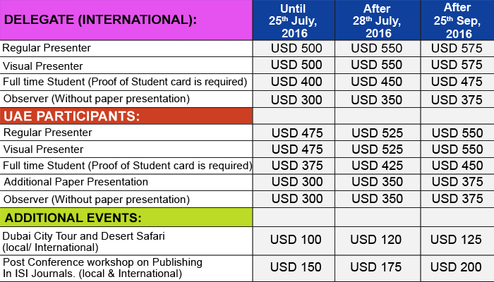

REGISTRATION FEE OF REGULAR/VISUAL/STUDENT PRESENTER INCLUDED:
Admission to the welcome reception and all session
- Card holder, Printed name card
- Conference bag & Pen
- Printed presenter certificate
- Refereed Proceeding CD/USB with ISBN
- Journal publication fees (Sponsored by GATR)
- Printed program Schedule
- Two coffee breaks each day
- International Buffet lunch daily

SECTION 3: PAYMENT INFORMATION

Option 1

You can pay registration fee by Bank Deposit / ATM Transfer / Online Transfer / Telegraphic Transfer. Please Visit: http://gcbss.org/cibssr/registration-payment.html

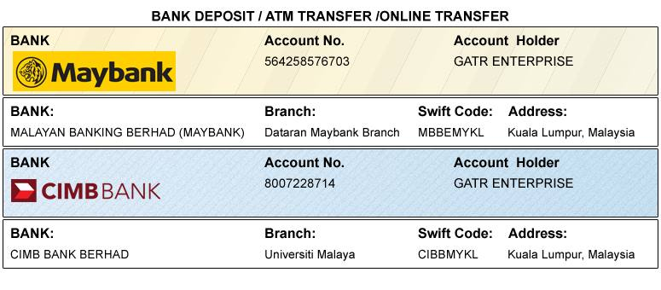

Option 2

You can pay registration fee through 2checkout Credit Card / Debit Card. Please visit how to pay at http://gcbss.org/cibssr/registration-payment.html

Option 3
Please download the form for Western Union payment from the link http://gcbss.org/cibssr/images/WesternUnion.doc. Western Union charges you a service fee (15.00-20.00 USD per transaction).

Declaration: I agree that I cannot claim back the registration fee I paid under any circumstance.
SIGNED:  (or write name here) |  | DATE:

