3rd DEANS AND DIRECTORS NETWORKING SESSION

Ambassador Hotel, Bangkok, Thailand

http://gcbss.org/cibssr2017/deans_&_directors_networking_session.html

3rd Deans and Directors Networking Session will be held during December 5, 2017, at Ambassador Hotel, Bangkok, Thailand. Please submit the filled Registration Form (.doc/.docx/), Proof of payment receipt to ids: gcbss2017@gmail.com and Cc. to admin@gcbss.org

SECTION 1: CONTACT INFORMATION:
6th GCBSS Paper ID Code: For example CIBSSR-00401
Name that you would like get printed on the certificate:

Networking Session Title: 3rd Deans and Directors Networking Session
Plan to attend the Networking session: € Yes € No (Visually attend through SKYPE)
Designation:(VC/Rector/Dean/Director/Professor/Assoc. Professor/Head of Department/other):

Full Affiliation/Organization/University and country Name:
(that you like to get printed on the certificate)

Telephone: | Mobile: | Email:
Special Needs or Dietary Requirements: € Yes € No

SECTION 2: REGISTRATION FEES:

Deans & Directors Registration Fee | Early  Until: 30 August,  2017 | Normal  Until: 15 October,  2017 | Late  Until: 15 November,  2017
Dean & Directors Networking Session Ticket | USD 100 | USD 150 | USD 175

Deans & Directors Registration includes:

Certificate of Participation

Printed program schedule.

Refreshment and drinks

SECTION 3: PAYMENT INFORMATION:

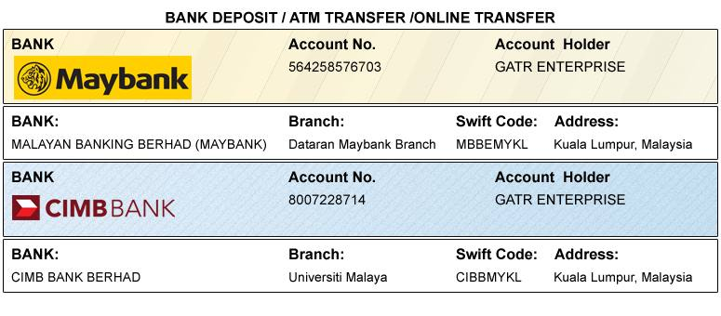
Option 1: Bank Deposit / ATM Transfer / Online Transfer / Foreign Telegraphic Transfer.

Option 2: PayPal / Credit Card / Debit Card:

Please visit: http://gcbss.org/cibssr2017/deans_&_directors_networking_session.html

PRIVACY POLICY:

The Global Academy of Training & Research (GATR) Division will protect your personal information. Your personal information received will only be used to fill your order. We will not sell or redistribute your information to anyone.

CANCELLATION POLICY:

You may cancel without penalty if written cancellation request are received up to and including 45 days prior to the start of the conference. A credit voucher less 50% of the registration fee will be issued for written requests received up to and including 25 days prior to the start of the conference. No refunds or credits will be issued on cancellation requests received less than 25 days prior to the start of the event. No liability is assumed by Global Conference on Business and Social Science for changes in program, date, content, speakers or venue.

PLEASE NOTE: Receipts will be provided on the Networking Session registration day (Dec 5, 2017) unless urgently required.

