REGISTRATION FORM OF 5th GCBSS CONFERENCE 2017
4-5 May, 2017, Connextion Vertical Hotel, Kuala Lumpur, Malaysia
http://gcbss.org/cimssr/registration.php

5th GCBSS will be held during 4-5 May, 2017, Connexion Vertical Hotel, Kuala Lumpur, Malaysia. Please note that it is essential for all participants to email the filled Registration Form (.doc/.docx/pdf) along with Proof of paymentreceipt to ids: admin@gcbss.organd Cc to gcbss2017@gmail.com

SECTION 1: CONTACT INFORMATION
Paper ID Code:For exampleCIMSSR-00101
Name that you would like get printed on the certificate:

Conference Title:5th Global Conference on Business and Social Science, Kuala Lumpur, Malaysia
Whether attend the Conference: € Yes€No
Position (Professor/Associate Prof/Assistant Professor/Lecturer/PhD Student/Master Student/other):

Full Affiliation/Organization/University and country Name:
(that you like get printed on the certificate)

Broad Field:i.e. Accounting |  | Are you willing to serve as a session chair:(Yes (No
Session Type: € Oral Presenter €Participant (Without paper) € Visual Presenter
Telephone: | Mobile: |  | Email:
Special Needs or Dietary Requirements: € Yes €No
Student ID Number of Your University (if applicable):
Paper Title:
Paper Pages: |  | Additional Page:

Notes:
- One regular registration can cover a paper within 8 pages, including all figures, tables, and references at 1.5 line spacing. If the length exceeds 8 pages the authors are required to pay a publication fee of USD 25.00 for each additional page.

- If number of authors are more than twoin manuscript authors are required to pay additional fees USD 50 for each additional author name.

- For additional Certificates for co-authors needs to pay USD 100 for each additional certificate.

SECTION 2: REGISTRATION FEESINFORMATION

Fee Schedule for 5th GCBSS Delegates: | Early  Until: February 28, 2017 | Normal  Until: March 28, 2017 | Late  Until: April 28, 2017
Regular Presenter (Lead Author) / Co-author | USD 525 | USD 550 | USD 600
Visual Presenter (Using Skype) | USD 525 | USD 550 | USD 600
Full Time Student | USD 425 | USD 450 | USD 500
Participant (Without paper) | USD 350 | USD 375 | USD 400
Additional Events for 5th GCBSS Delegates:
Dean & Directors Networking Session Tickets | USD 100 | USD 150 | USD 175
Post Conference workshop on Publishing in ISI (SSCI & SCI Indexed) Journals. For 5th GCBSS delegates | USD 100 | USD 120 | USD 150
Post Conference workshop on Publishing in ISI (SSCI & SCI Indexed) Journals. Non GCBSS Delegates | USD 175 | USD 200 | USD 225
Conference Tour | USD 50 | USD 75 | USD 100

GATR/GCBSS Policy:

- The lecturer cum student will not be considered for student rate
- Full-time student must need to submit a valid student ID card
- Daily Market Conversion Rate is applicable to all USD prices.
- Service/Transfer Fees are not included in above prices.

Registration fee of Regular/Visual/Student Presenter Included:

Admission to the welcome reception and parallel session

- Conference KIT (includes: bag, notebook, pen, name card)
- Printed presenter certificate
- Refereed Proceeding CD or USB with ISBN
- Journal publication fees (Sponsored by GATR)
- Printed brief program Schedule
- Two coffee breaks each day
- International Buffet lunch daily

Registration Fee of Participant Included:

Admission to the welcome reception and parallel session

- Conference KIT (includes: bag, notebook, pen, name card)
- Printed participant certificate
- Printed brief program Schedule
- Two coffee breaks each day
- International Buffet lunch daily

SECTION 3: PAYMENT INFORMATION

Option 1

You can pay registration fee by Bank Deposit / ATM Transfer / Online Transfer / Telegraphic Transfer in Co. Account. Please Visit:http://gcbss.org/cimssr/registration-payment.html
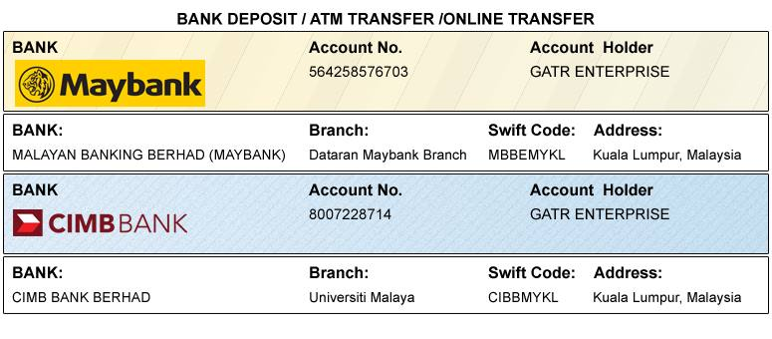

Option 2

You can pay registration fee through 2checkout Credit Card /Debit Card/PayPal.Please visit how to pay at hhttp://gcbss.org/cimssr/registration-payment.html

Option 3
Please download the form for Western Union payment from the link: http://gcbss.org/cimssr/registration-payment.html. Western Union charges you a service fee (15.00-20.00 USD per transaction).

Declaration:I agree that I cannot claim back the registration fee I paid under any circumstance.
SIGNED:  (or write name here) |  | DATE:

