5THANNUAL GLOBAL CONFERENCE ON BUSINESS AND SOCIAL SCIENCES (5th GCBSS 2017)

DEANS & DIRECTORS REGISTRATION FORM

4-5 May, 2017, Kuala Lumpur, Malaysia
http://gcbss.org/cimmr/index.html

5TH Annual Global Conference on Business and Social Sciences 2017 will be held during 4-5 May, 2017, Kuala Lumpur, Malaysia. Please submit the filled Registration Form (.doc/.docx/), Proof of payment receiptto ids: gcbss2017@gmail.comand Cc to admin@gcbss.org

SECTION 1: CONTACT INFORMATION:
Paper ID Code: For exampleCIMSSR-00401
Name that you would like get printed on the certificate:

Conference Title:5th Annual Global Conference on Business and Social Sciences
Plan to attend the conference: € Yes € No
Designation:(VC/Rector/Dean/Director/Professor/Assoc. Professor/Head of Department/other):

Full Affiliation/Organization/University and country Name:
(that you like to get printed on the certificate)

Telephone: | Mobile: |  | Email:
Special Needs or Dietary Requirements: € Yes €No
Conference Track: i.e. Finance |  | Are you willing to serve as a session chair: (Yes (No
Session Type: € Oral Presenter €Participant (Without Paper)
Paper Title:
Paper Pages: |  | Additional Page:

Note:
- One regular registration can cover a paper within 8 pages, including all figures, tables, and references. If the length exceeds 8 pages the authors are required to pay a publication fee of USD 20.00 for each additional page.

- If number of authors are more than four in manuscript authors are required to pay additional fees USD 50 for each additional author name.

- For additional Certificates for co-authors needs to pay USD 100 for each additional certificate.

SECTION 2: REGISTRATION FEESINFORMATION:

Deans & Directors Registration Fee | Early  Until: February 28,  2017 | Normal  Until: March 28,  2017 | Late  Until: April 28,  2017
Dean & Directors Networking Session Ticket | USD 100 | USD 150 | USD 175

Deans & Directors Registration includes:
- Exclusive, expedited check-in at the 5th GCBSS Opening Session.
- Reserved front row seating at the General Session & Opening Keynote, Award Luncheon and Conference Finale.
- Conference name badge, Proceeding CD and materials delivered to your hotel.
- Printed program schedule.
- Annual DD Networking Session E-Ticket.
- Sovereign in Closing Ceremony
- Journal publication fees (Sponsored by GATR)

SECTION 3: PAYMENT INFORMATION:

Option 1:You can pay registration by Bank Deposit / ATM Transfer / Online Transfer / Foreign Telegraphic Transfer.

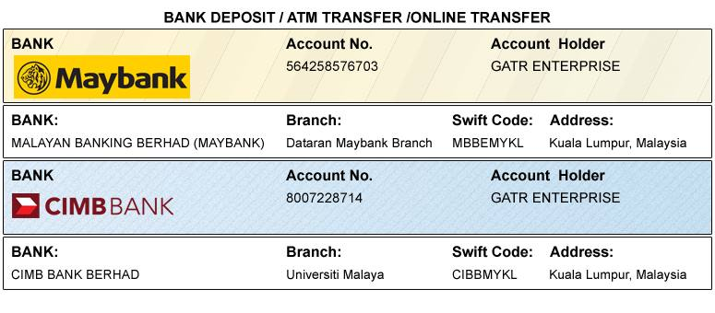

Option 2PayPal / Credit Card / Debit Card:

If you have a credit card or 2checkout account, we strongly encourage you to pay the fee through 2checkout. 2checkout enables users, whether or not they are 2checkout members, to use all major credit cards, including Visa,Master card, American Express, and Discover. 2checkout is fast and secure.Please visit how to pay at:http://gcbss.org/cimssr/registration-payment.html

PLEASE NOTE:Receipts will be provided on the conference registration day (4 May 2017,) unless urgently required.
SIGNED:  (or write name here) |  | DATE:

