Registration Form – 18th Global Conference on Business and Social Sciences (GCBSS 2026)

6-7 August 2026
CHATRIUM HOTEL RIVERSIDE BANGKOK, THAILAND
(IN-PERSON & ONLINE)
http://gcbss.org/Registration-Payment.html

The 18th GCBSS will take place on August 6-7, 2026, at Chatrium Hotel Riverside Bangkok, Thailand. The event will be available both in-person and online. Please ensure that all participants email the completed Registration Form (in .doc, .docx format) along with the proof of payment receipt to admin@gcbss.org, and kindly CC register@gatrenterprise.com.

SECTION 1: CONTACT INFORMATION
Paper ID Code: For example, CIBSSR-00201
Please ensure this matches the ID provided in your acceptance email.
Full Name (as to appear on certificate):

Conference Title: 18th Global Conference on Business and Social Science, Bangkok, Thailand.
Attendance Mode: € In-Person € Online
Position (Professor/Associate Prof/Assistant Professor/Lecturer/PhD Student/Master Student/other):

Institution & Country (for certificate):

Field of Study (e.g., Accounting, Management, Education) | Are you willing to serve as a session chair: € Yes € No
Session Type:€ Oral Presenter € Poster € 3 Minutes PhD proposal € Visual Presenter (ZOOM)
Phone (with country code): |  |  | Email:
Any dietary or accessibility requirements? € Yes €No – please specify
Fulltime Student ID Number of Your University (if applicable):
Abstract/Paper Title:
Total Paper Length (No. of Pages): |  | Additional Pages (if more than 8):
Are you interested in joining the Conference Tour: € Yes € No
Are you interested in attending the GALA Dinner & Networking: € Yes € No
Are you interested in attending the Workshop: € Yes € No
Are you interested in joining the Academic Discussion Session: € Yes € No

Notes:
- A regular registration covers a paper of up to 8 pages, including all figures, tables, and references, with a line spacing of 1.5. If the Paper exceeds 8 pages, authors must pay an additional fee of USD 25.00 for each extra page.

- If there are more than two authors for the manuscript, additional fees of USD 50.00 will be required for each additional author.

- For extra certificates, co-authors must pay USD 100 for each certificate requested.

SECTION 2: REGISTRATION FEES INFORMATION

18th GCBSS 2026 Fee Schedule: | Early-Bird  Until:  30 March 2026 | Standard  Until:  30 May 2026 | Late  Until:  30 July 2026
Oral/Poster Presenter (lead or co-author) | USD 525 | USD 575 | USD 600
Visual Presenter (Zoom-based, journal pipeline + full access; GMT+7) | USD 500 | USD 525 | USD 550
Full-time Student (valid student ID required) | USD 425 | USD 475 | USD 500
Additional Paper (same presenter) | USD 325 | USD 350 | USD 375
Attendee (without abstract/paper) | USD 300 | USD 325 | USD 350
Online Attendee (without abstract/paper) | USD 100 | USD 100 | USD 100
Additional Events for 18th GCBSS Delegates:
Gala Dinner & Networking on 6 August 2026 | FREE | FREE | FREE
Research Development Workshop (Grants & Publishing)  7 August 2026, hybrid (Zoom link, GMT+7, Bangkok) | FREE | FREE | FREE
Note: All fees are in USD. Conversion rates may apply based on your local currency.
Bank/service fees are not included.

GATR/GCBSS Policy:

- Lecturers who are also students are not eligible for student rates
- Full-time students must provide a valid student ID and a letter from the Dean.

Registration fee for Oral/Poster/Student Presenter includes:

- Admission to the welcome reception and all sessions
- Conference kit
- Printed presenter certificate with official seal (lead and second author)
- Access to the Program website
- e-abstract publication & e-proceedings (ISBN)
- Journal publication fees (sponsored by GATR; subject to paper acceptance and editorial decision)
- Research Development Workshop (Grants & Publishing)
- Two coffee breaks each day
- International buffet lunch daily
- Gala Dinner & Networking
- Free GCBSS membership for 12 months

Registration fee for Visual/Online Presenter includes:

- Admission to the welcome reception and all sessions
- Presenter e-certificate with official seal (lead and second author)
- e-abstract publication & e-proceedings (ISBN)
- Journal publication fees (sponsored by GATR; subject to paper acceptance and editorial decision)
- Access to the Program website
- Research Development Workshop (Grants & Publishing), hybrid (Zoom link, GMT+7)
- Free GCBSS membership for 12 months

Registration fee for Attendee includes:

- Admission to all sessions
- Participation certificate with official seal
- Access to the Program website
- Research Development Workshop (Grants & Publishing)
- Free GCBSS membership for 12 months

SECTION 3: PAYMENT INFORMATION

OPTION 1

Bank Transfer (ATM, Online, or Wire Transfer) in the Company's official account.

Please visit: http://gcbss.org/Registration-Payment.html
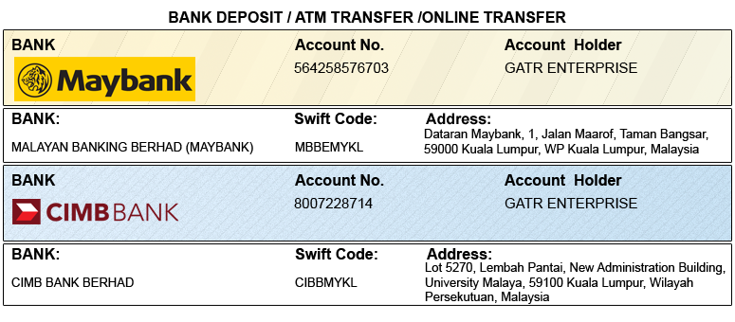

OPTION 2

Credit Card / Debit Card / PayPal / 2Checkout Account to GATR 2Checkout official account. Registered official email: info@gatrenterprise.com

Please visit http://gcbss.org/Registration-Payment.html

Please include your Paper ID in the payment reference for accurate tracking. Note: A 5% transaction fee applies to card payments.

PRIVACY POLICY:

The Global Academy of Training & Research (GATR) Division is committed to protecting your personal information. The information we collect will only be used to fulfill your order, and we will not sell or share your information with anyone.

CANCELLATION POLICY:

• ≥ 45 days before: 100% credit voucher
• 44–25 days before: 50% credit voucher
• < 25 days before: No refunds or credits

Please note that the Global Conference on Business and Social Science is not liable for any changes in the program, date, content, speakers, or venue.

Declaration: I understand and accept that the registration fee is non-refundable under any circumstances.
SIGNED:  (or write your name here) |  | DATE:
PLEASE NOTE: Original receipts will be emailed to registered guests before the Conference for claim purposes.

